Purpose: Day 2 ClassWork and Assignment
Date: 22/12/2025
Author: Vinayak Majhi
ID: 58618

Classwork
(NotePad)

Q.1) 1. Accept a number : 10
10 11 12 13 ... 19
10 100 110 120 130 190
11 110 121 132 143 . .. 209
12
.
.
19

#include <stdio.h>

int main() {
int n, i, j;

printf("Accept a number: ");
scanf("%d", &n);

for (i = n; i <= n + 9; i++) {
for (j = n; j <= n + 9; j++) {
printf("%d\t", i * j);
}
printf("\n");
}

return 0;
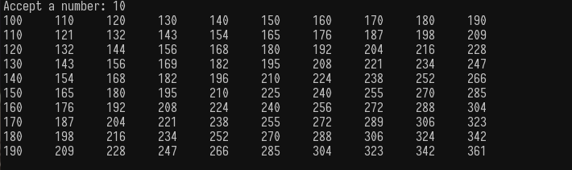

Q.2) Accept a number and print the next 25 prime numbers starting from that number.

#include <stdio.h>

int main() {
int num, count = 0, i, isPrime;

printf("Accept a number: ");
scanf("%d", &num);

num++;

while (count < 25) {
isPrime = 1;

for (i = 2; i * i <= num; i++) {
if (num % i == 0) {
isPrime = 0;
break;
}
}

if (isPrime && num > 1) {
printf("%d ", num);
count++;
}

num++;
}

return 0;
}

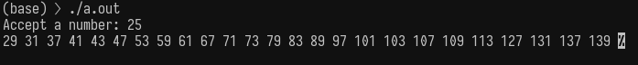

Q.2) Implement a function isPrime(num), taking number as an argument returning integer (0 or 1 for false or true).

#include <stdio.h>

int isPrime(int num) {
int i;

if (num <= 1)
return 0;

for (i = 2; i * i <= num; i++) {
if (num % i == 0)
return 0;
}

return 1;
}

int main() {
int num;

printf("Enter a number: ");
scanf("%d", &num);

if (isPrime(num))
printf("%d is a prime\n", num);
else
printf("%d is NOT a prime\n", num);

return 0;
}
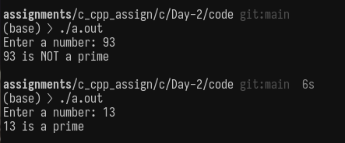

Q.3) Implement printCalendarV1.c by dividing the logic into sub-tasks(functions). Function names and prototypes given below.
int isLeap(Year);//
int maxDays(month, Year); //
int dayOfWeek(day, month, Year);
void printCalendar(month, Year);
------------------------------------------------------------

#include <stdio.h>

int isLeap(int year) {
if ((year % 4 == 0 && year % 100 != 0) || (year % 400 == 0))
return 1;
return 0;
}

int maxDays(int month, int year) {
if (month == 2)
return isLeap(year) ? 29 : 28;

if (month == 4 || month == 6 || month == 9 || month == 11)
return 30;

return 31;
}

int dayOfWeek(int d, int m, int y) {
if (m < 3) {
m += 12;
y -= 1;
}

return (d + (13 * (m + 1)) / 5 + y + (y / 4)
- (y / 100) + (y / 400)) % 7;
}

void printCalendar(int month, int year) {
int days, w, i;

days = maxDays(month, year);
w = (dayOfWeek(1, month, year) + 6) % 7;

printf("\nSu Mo Tu We Th Fr Sa\n");

for (i = 0; i < w; i++)
printf(" ");

for (i = 1; i <= days; i++) {
printf("%2d ", i);
if ((i + w) % 7 == 0)
printf("\n");
}
printf("\n");
}

int main() {
int month, year;

printf("Enter Month and Year: ");
scanf("%d %d", &month, &year);

printCalendar(month, year);

return 0;
}

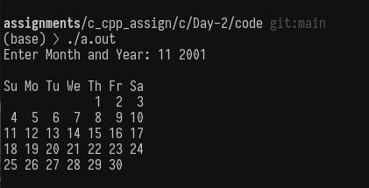

Q.4). Declare an array of integers for storing 100 elements. Accept the first element from the user. Assign the next 99 values by running a loop. Print the array data/contents.

printf("Enter the first value: ");
scanf("%d", &arr[0]);

Enter the first Value: 100
100 101 102 103 104 .... 199

#include <stdio.h>

int main() {
int arr[100];
int i;

printf("Enter the first value: ");
scanf("%d", &arr[0]);

for (i = 1; i < 100; i++) {
arr[i] = arr[i - 1] + 1;
}

for (i = 0; i < 100; i++) {
printf("%d ", arr[i]);
}

return 0;
}

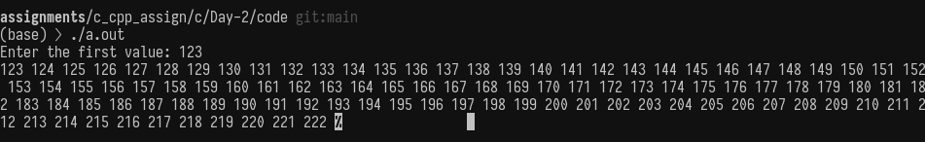

Q.5). Use the function isPrime(num) written early, to check individual elements in the array for prime or not. If the element is prime, leave it as it is, else make the element 0. At the end you will have an array of prime numbers and zeros.

Enter the first Value: 100
100 101 102 103 104 .... 199
0 101 0 103 0 0 0 107 ... 197 0 199
-----------------------

#include <stdio.h>

int isPrime(int num) {
int i;

if (num <= 1)
return 0;

for (i = 2; i * i <= num; i++) {
if (num % i == 0)
return 0;
}
return 1;
}

int main() {
int arr[100];
int i;

printf("Enter the first value: ");
scanf("%d", &arr[0]);

for (i = 1; i < 100; i++) {
arr[i] = arr[i - 1] + 1;
}

for (i = 0; i < 100; i++) {
printf("%d ", arr[i]);
}

printf("\n");

for (i = 0; i < 100; i++) {
if (!isPrime(arr[i])) {
arr[i] = 0;
}
}

for (i = 0; i < 100; i++) {
printf("%d ", arr[i]);
}

return 0;
}

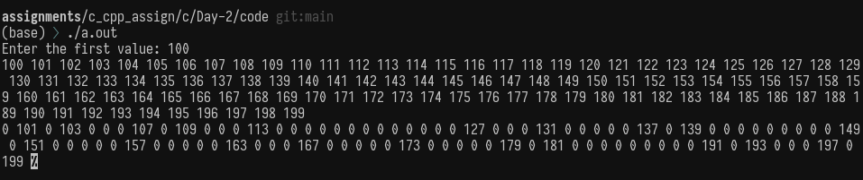

Q.6. Custom String Functions

#include <stdio.h>

int myStrLen(const char str[]) {
int i = 0;

while (str[i] != '\0') {
i++;
}
return i;
}

char *myStrCpy(char dest[], const char src[]) {
int i = 0;

while (src[i] != '\0') {
dest[i] = src[i];
i++;
}
dest[i] = '\0';

return dest;
}

char *myStrCat(char dest[], const char src[]) {
int i = 0, j = 0;

while (dest[i] != '\0') {
i++;
}

while (src[j] != '\0') {
dest[i] = src[j];
i++;
j++;
}
dest[i] = '\0';

return dest;
}

int myStrCmp(const char str1[], const char str2[]) {
int i = 0;

while (str1[i] != '\0' && str2[i] != '\0') {
if (str1[i] != str2[i])
return str1[i] - str2[i];
i++;
}

return str1[i] - str2[i];
}

int main() {
char s1[100] = "Vinayak";
char s2[100] = "Majhi";
char s3[100];

printf("Length of s1: %d\n", myStrLen(s1));

myStrCpy(s3, s1);
printf("After copy, s3: %s\n", s3);

myStrCat(s3, s2);
printf("After concat, s3: %s\n", s3);

printf("Compare s1 and s2: %d\n", myStrCmp(s1, s2));
printf("Compare s1 and s1: %d\n", myStrCmp(s1, s1));

return 0;
}

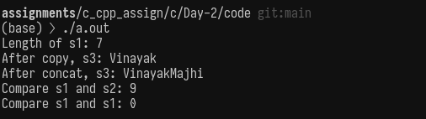

Assignments (Excel Sheet)
(From 20/12/2025-22/12/2025)

Q.1) Write a program that asks the user for various types of data and prints them in a formatted manner.
#include <stdio.h>

int main() {
int age;
float height;
char grade;
char name[50];

printf("Enter name: ");
scanf("%s", name);

printf("Enter age: ");
scanf("%d", &age);

printf("Enter height: ");
scanf("%f", &height);

printf("Enter grade: ");
scanf(" %c", &grade);

printf("\n--- User Details ---\n");
printf("Name : %s\n", name);
printf("Age : %d\n", age);
printf("Height : %.2f\n", height);
printf("Grade : %c\n", grade);

return 0;
}

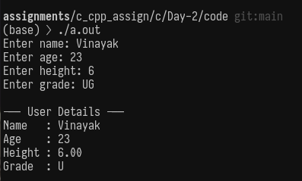

Q.2) Create a calculator that takes two numbers and an operation from the user and displays the result
#include <stdio.h>

int main() {
int a, b;
char op;

printf("Enter two numbers: ");
scanf("%d %d", &a, &b);

printf("Enter operation (+ - * /): ");
scanf(" %c", &op);

if (op == '+')
printf("Result: %d\n", a + b);
else if (op == '-')
printf("Result: %d\n", a - b);
else if (op == '*')
printf("Result: %d\n", a * b);
else if (op == '/')
printf("Result: %d\n", a / b);
else
printf("Invalid operation\n");

return 0;
}

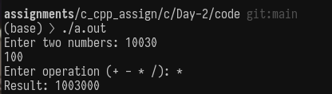

Q.3) Write a program that categorizes a numerical grade into a letter grade

#include <stdio.h>

int main() {
int marks;

printf("Enter marks: ");
scanf("%d", &marks);

if (marks >= 90)
printf("Grade A\n");
else if (marks >= 75)
printf("Grade B\n");
else if (marks >= 60)
printf("Grade C\n");
else if (marks >= 40)
printf("Grade D\n");
else
printf("Grade F\n");

return 0;
}

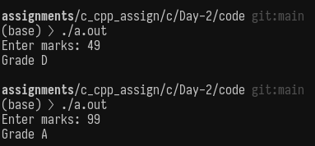

Q.4) Create a program that uses a switch statement to perform arithmetic operations

#include <stdio.h>

int main() {
int a, b;
char op;

printf("Enter two numbers: ");
scanf("%d %d", &a, &b);

printf("Enter operation (+ - * /): ");
scanf(" %c", &op);

switch (op) {
case '+': printf("Result: %d\n", a + b); break;
case '-': printf("Result: %d\n", a - b); break;
case '*': printf("Result: %d\n", a * b); break;
case '/': printf("Result: %d\n", a / b); break;
default: printf("Invalid operation\n");
}

return 0;
}

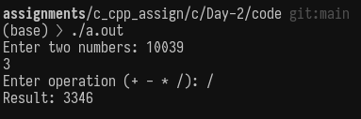

Q.5. Construct a program that uses both if and switch to navigate menu options
#include <stdio.h>

int main() {
int choice, a = 10, b = 5;

printf("1.Add\n2.Subtract\n3.Multiply\nEnter choice: ");
scanf("%d", &choice);

if (choice >= 1 && choice <= 3) {
switch (choice) {
case 1: printf("Sum = %d\n", a + b); break;
case 2: printf("Difference = %d\n", a - b); break;
case 3: printf("Product = %d\n", a * b); break;
}
} else {
printf("Invalid choice\n");
}

return 0;
}

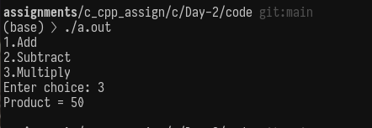

Q.6. Create a calculator using functions for each arithmetic operation
#include <stdio.h>

int add(int a, int b) { return a + b; }
int sub(int a, int b) { return a - b; }
int mul(int a, int b) { return a * b; }
int div(int a, int b) { return a / b; }

int main() {
int a, b;

printf("Enter two numbers: ");
scanf("%d %d", &a, &b);

printf("Add = %d\n", add(a, b));
printf("Sub = %d\n", sub(a, b));
printf("Mul = %d\n", mul(a, b));
printf("Div = %d\n", div(a, b));

return 0;
}
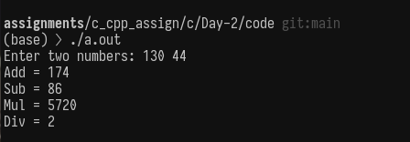
Q.7. Write a recursive function to calculate the nth Fibonacci number

#include <stdio.h>

int fib(int n) {
if (n == 0) return 0;
if (n == 1) return 1;
return fib(n - 1) + fib(n - 2);
}

int main() {
int n;

printf("Enter n: ");
scanf("%d", &n);

printf("Fibonacci = %d\n", fib(n));

return 0;
}

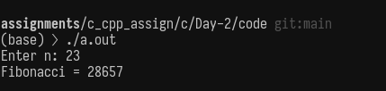
Q.8. Develop a function that converts temperature between Celsius and Fahrenheit

#include <stdio.h>

float cToF(float c) {
return (c * 9 / 5) + 32;
}

float fToC(float f) {
return (f - 32) * 5 / 9;
}

int main() {
float temp;
int choice;

printf("1.C to F\n2.F to C\nEnter choice: ");
scanf("%d", &choice);

printf("Enter temperature: ");
scanf("%f", &temp);

if (choice == 1)
printf("Result: %.2f F\n", cToF(temp));
else
printf("Result: %.2f C\n", fToC(temp));

return 0;
}
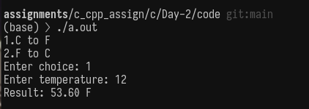

Q.9. Implement your own version of the strlen function
#include <stdio.h>

int myStrLen(const char str[]) {
int i = 0;
while (str[i] != '\0')
i++;
return i;
}

int main() {
char str[100];

printf("Enter string: ");
scanf("%s", str);

printf("Length = %d\n", myStrLen(str));

return 0;
}

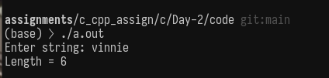
Q.10. Write a program that concatenates two strings without using strcat

#include <stdio.h>

int main() {
char s1[100], s2[50];
int i = 0, j = 0;

printf("Enter first string: ");
scanf("%s", s1);

printf("Enter second string: ");
scanf("%s", s2);

while (s1[i] != '\0')
i++;

while (s2[j] != '\0') {
s1[i] = s2[j];
i++;
j++;
}
s1[i] = '\0';

printf("Concatenated string: %s\n", s1);

return 0;
}

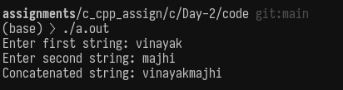
Q. 11. Create a string reverse function and test it

#include <stdio.h>

void reverse(char str[]) {
int i = 0, j;
char temp;

while (str[i] != '\0')
i++;
j = i - 1;

i = 0;
while (i < j) {
temp = str[i];
str[i] = str[j];
str[j] = temp;
i++;
j--;
}
}

int main() {
char str[100];

printf("Enter string: ");
scanf("%s", str);

reverse(str);
printf("Reversed string: %s\n", str);

return 0;
}

